Batch: A2. Roll No.: 16010121045

Experiment / assignment / tutorial No. 4

Grade: AA / AB / BB / BC / CC / CD /DD

Signature of the Staff In-charge with date

TITLE: Program to print patterns

AIM: Program to print patterns for ‘n’ rows using nested loop ______________________________________________________________________
Expected OUTCOME of Experiment:
CO2: Applying basic concepts of C programming for problem solving.
_____________________________________________________________________
Books/ Journals/ Websites referred:

- Programming in C, second edition, Pradeep Dey and Manas Ghosh, Oxford University Press.
- Programming in ANSI C, fifth edition, E Balagurusamy, Tata McGraw Hill.
- Introduction to programming and problem solving , G. Michael Schneider ,Wiley India edition.
- http://cse.iitkgp.ac.in/~rkumar/pds-vlab/

_____________________________________________________________________

Problem Definition:

The program is to print a pattern as given by the user. The program makes use of a nested loop to print a pattern of characters, numbers or alphabets.

Example:
Input: number of rows = 4, number of columns = 4

Output:
5
4 5
3 4 5
2 3 4 5
1 2 3 4 5

Algorithm:

Main()
- Start
- Declare n
- Ask the user to enter the number of rows
- Read the value of n
- Call patt1(n)
- Call patt2(n)
- Call patt3(n)
- Call patt4(n)
- Call patt5(n)
- Call pass(n)

Pass(n)
- Start
- Print “Pascal's triangle Pattern”
- Declare i=0
- While i<n
1. Declare k=i
2. While k<=n
1. Print space “ “
2. k=k+1
3. End While
4. Declare j=0
5. While j<=i
1. print ncr(i,j)
2. j=j+1
6. End While
7. i=i+1
- End While
- End.

int ncr(n,r)
- Start
- Declare ans=1
- Declare i=n
- While i>0
1. ans=ans*i
2. i=i-1
- End While
- Declare ans1=1
- Declare i=n
- While i>0
1. ans1=ans1*i
2. i=i-1
- End While
- Declare ans2=1
- Declare i=n
- While i>0
1. ans2=ans2*i
2. i=i-1
- End While
- Return ans/(ans1*ans 2)
- End

Implementation details:

#include<stdio.h>
void patt1(int n)
{
printf("First Pattern \n\n");
for(int i=1;i<=n;i++)
{
for(int j=1;j<=i;j++)
printf("* ");
printf("\n");
}
printf("\n\n");
}
void patt2(int n)
{
printf("Second Pattern \n\n");
for(int i=n;i>0;i--)
{
for(int j=1;j<=i;j++)
printf("* ");
printf("\n");
}
printf("\n\n");
}
void patt3(int n)
{
printf("Third Pattern \n\n");
int count=1;
int ii=1;
for(int i=n;i>=1;i--)
{
for(int j=1;j<=i*2;j++)
printf(" ");
ii=n-i+1;
for(int j=1;j<=count;j++)
{
if(j>(count/2))
printf(" %d",ii--);
else
printf(" %d",ii++);
}
printf("\n");
count+=2;
ii++;
}
printf("\n\n");
}
void patt4(int n)
{
printf("Fourth Pattern \n\n");
for(int i=1;i<n;i++)
{
for(int j=i;j<n;j++)
printf(" ");
for(int j=1;j<i*2;j++)
{
printf("*");
}
printf("\n");
}
for(int i=n;i>=1;i--)
{
for(int j=1;j<i*2;j++)
{
printf("*");
}
printf("\n");
for(int j=i;j<=n;j++)
printf(" ");
}
printf("\n\n");
}
void patt5(int n)
{
printf("Fifth Pattern \n\n");
for(int i=1;i<=n;i++)
{
char k='A';
for(int j=1;j<=i;j++)
printf("%c ",k++);
printf("\n");
}
printf("\n\n");
}
int ncr(int n,int r)
{
int ans=1;
for(int i=n;i>0;i--)
ans*=i;
int ans1=1;
for(int i=r;i>0;i--)
ans1*=i;
int ans2=1;
for(int i=(n-r);i>0;i--)
ans2*=i;
return ans/(ans1*ans2);
}
void pass(int n)
{
printf("Pascal's triangle Pattern \n\n");
for(int i=0;i<n;i++)
{
for(int k=i;k<=n;k++)
printf(" ");
for(int j=0;j<=i;j++)
printf(" %3d",ncr(i,j));
printf("\n");
}
printf("\n\n");
}
int main()
{
printf("Enter a Value for n\n");
int n;
scanf("%d",&n);
patt1(n);
patt2(n);
patt3(n);
patt4(n);
patt5(n);
pass(n);
return 0;

Output(s):
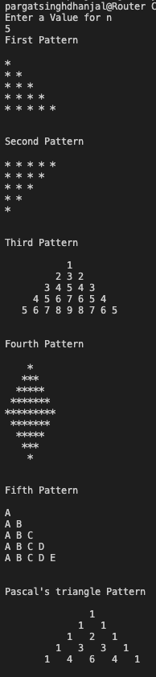
Conclusion:

Exp. 4 has been successfully completed and implemented.

Post Lab Descriptive Questions:

Write a program to print the following:
1
2 4
3 6 9
4 8 12 16
5 10 15 20 25
6 12 18 24 30 36
7 14 21 28 35 42 49
8 16 24 32 40 48 56 64
9 18 27 36 45 54 63 72 81
10 20 30 40 50 60 70 80 90 100

Implementation details:

#include<stdio.h>
int main() {
int n;
printf("Enter the number of rows: ");
scanf("%d",&n);
for(int i=1;i<=n;i++)
{
for(int j=1;j<=i;j++)
printf("%3d ",(i*j));
printf("\n");
}
printf("\n\n");
return 0;
}

Output:

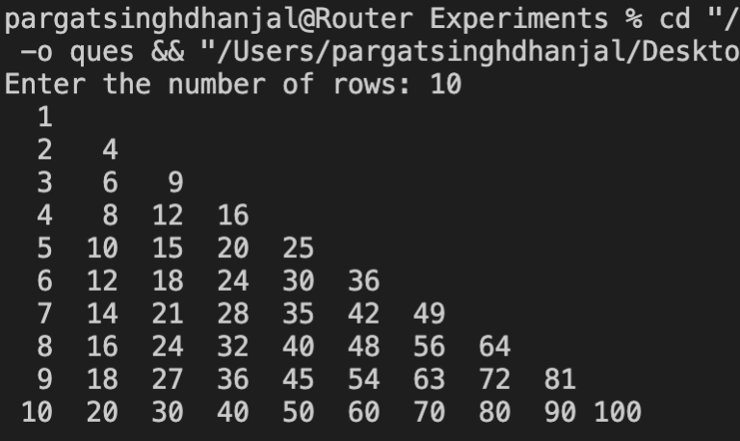

Date: 2/12/2021 Signature of faculty in-charge

